SE Australia Nautical Institute - February Quarterly branch meeting
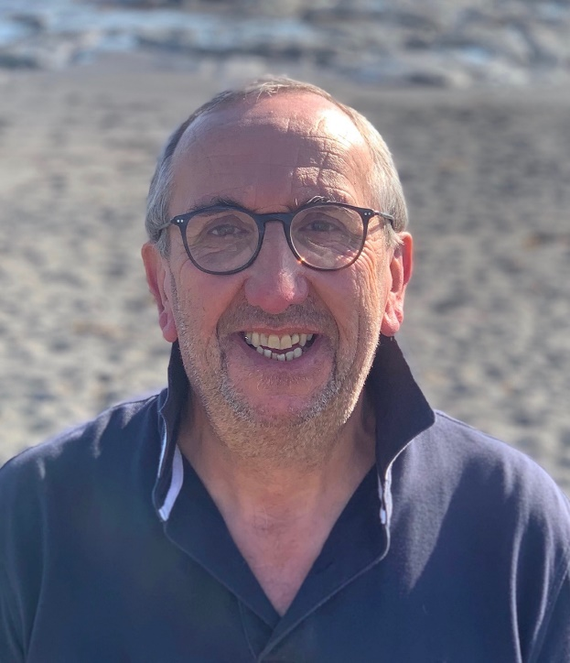

Wednesday 12th February @ 1800 – Quarterly branch meeting - Capt. Rob Tanner, Senior Marine Pilot, Port Kembla. The Occidental hotel, Sydney CBD.
We are very fortunate to have another Port Kembla Marine Pilot presenting at our quarterly branch meeting. NI member Capt. Rob Tanner, Senior Marine Pilot, Port Kembla has very kindly agreed to speak on an area that greatly interests him.
The topic is Humans and Autonomous ships - Technology has historically been created for the purpose of assisting humans and improving productivity. It is claimed that a large percentage of maritime incidents are attributable to human error, and by increasing the autonomy of a vessel it will correspondingly decrease those incidents. System design engineers assert that humans and onboard autonomous systems will need to work alongside each other so they augment each other’s capabilities. A human centred approach is therefore required when considering the design of shipboard systems, whilst correspondingly the maritime industry will need to address the skill levels and knowledge requirements of the future seafarer.
Please RSVP myself by text on 0437681277 or pawalshe@hotmail.com & Frank Pickering fpickering6@bigpond.com with any dietary requirements by 1200 Monday 10th February.
Best regards,

Capt. Patrick Walsh AFNI
Assist Secretary SE Australia NI branch.
Mob: 0437681277
Join the SE Australia NI branch Group page on LinkedIn for the latest branch news and updates https://www.linkedin.com/groups/13746709/

